**Question: 01**

**Write a program in Java that takes input from the user and check whether the number is positive or negative.**

**Source Code:**

**import java.util.Scanner;**

**public class OopLabQuiz_02 {**

**public static void main(String args[]) {**

**Scanner input = new Scanner(System.in);**

**System.out.print("Enter the number: ");**

**int num = input.nextInt();**

**if(num >= 0) {**

**System.out.println(num + " is positive");**

**} else {**

**System.out.println(num + " is negative");**

**}**

**}**

**OUTPUT:**

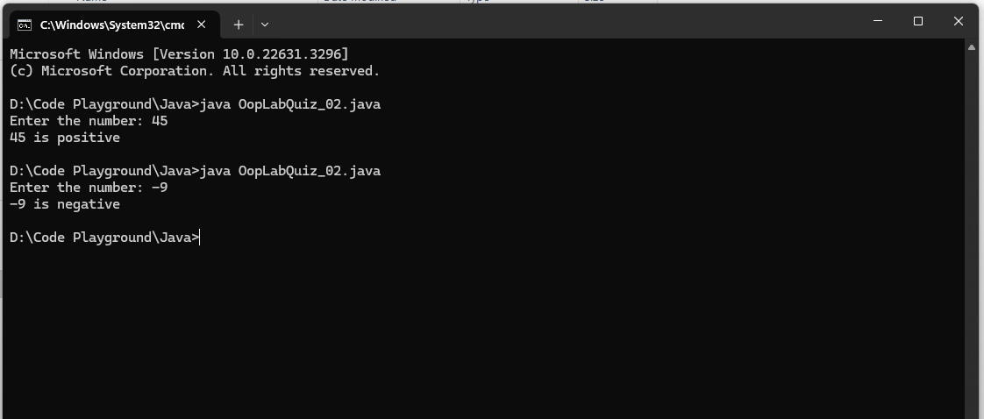

**Question: 02**

**Write a java program to Take values of length and breadth of a rectangle from user and check if it is square or not.**

**Source Code:**

**import java.util.Scanner;**

**public class OopLabQuiz_02 {**

**public static void main(String args[]) {**

**Scanner input = new Scanner(System.in);**

**System.out.print("Enter the value of length of the rectangle: ");**

**float length = input.nextFloat();**

**System.out.print("Enter the value of breadth of the rectangle: ");**

**float breadth = input.nextFloat();**

**if(length == breadth) {**

**System.out.println("It is square :)");**

**} else {**

**System.out.println("It is not square ):");**

**}**

**}**

**}**

**OUTPUT:**

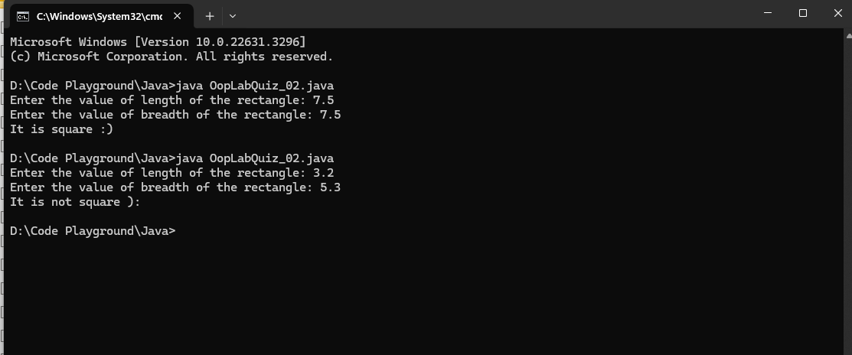

**Question: 03**

**Write a java program to Take values of length and breadth of a rectangle from user and check if it is square or not.**

**Source Code:**

**import java.util.Scanner;**

**public class OopLabQuiz_02 {**

**public static void main(String args[]) {**

**Scanner input = new Scanner(System.in);**

**System.out.print("Enter the value of length of the rectangle: ");**

**float length = input.nextFloat();**

**System.out.print("Enter the value of breadth of the rectangle: ");**

**float breadth = input.nextFloat();**

**if(length == breadth) {**

**System.out.println("It is square :)");**

**} else {**

**System.out.println("It is not square ):");**

**}**

**}**

**}**